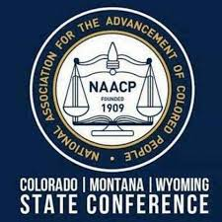
Consent Form 2023
I, ______________________________________________ consent to serve as a candidate for the Office of ______________________________________ or as a candidate for the position of At-Large Executive Committee member in the NAACP CO-MT-WY State Area Conference. If elected, I agree to serve under and abide by the policies and procedures of the NAACP. If I have not completed NAACP mandatory training, I agree to complete mandatory training by a date to be set by the National Office and publicized by the State Area Conference. Branch. If elected, I agree to serve and abide by the policies, principles and procedures of the NAACP, I agree to complete Executive Leadership Training by May 31, 2023. For the purpose of serving as a candidate for an elected office I affirm that I have been a bona fide member of the Branch as of May 1, 2022, that my membership has remained continuous, and that I live and/or work within the jurisdiction of the Branch.
NAACP Petition for Nomination
We, the undersigned wish to nominate ______________________________________________
__________________________________ for the Office of ____________________________ or as an At-Large member of the Executive Committee. (A valid petition must contain at least 3 signatures. Those who sign petitions must be a member of a Unit in good standing within the State Area Conference at least 30 days before the date of signature.)
Signature/Date
1___________________________________________________________________________
2____________________________________________________________________________
3____________________________________________________________________________
Please Return This Form to secretary@rmnaacp.org or PO Box 31671, Aurora CO 80041 not later than March 12, 2023

